IS MATHEMATICS INVENTED OR DISCOVERED BY HUMANS?

Michael. Gr. Voskoglou

Graduate Technological Educational Institute of Western Greece
mvosk @ hol.gr

ABSTRACT

Is mathematics a discovery or an invention of the human mind? This is the question raised and investigated in the article in hands, a question that has occupied the interest of philosophers and mathematicians for centuries, at least from the Plato’s era. The development of the non Euclidean Geometries as well as some consequences of the axiomatic development of Set Theory caused two strong blows to the Platonic view that mathematics is a human discovery. A series of experimental data on the correlation of mathematics with human mind are also indicating that mathematics is a human invention. Nevertheless, many people until today are still supporting the Plato’s ideas, whereas there exist also considerations putting the truth somewhere in the middle between the above two extreme vies. However, it seems that the unique certain conclusion which could be obtained from such a discussion is that mathematics constitutes an inseparable part of the human civilization.

Keywords: Philosophy of Mathematics, Platonism, Mathematical Realism, Non Euclidean Geometries, Set Theory, Continuum Hypothesis, Axiom of Choice, Incompleteness Theorems, Canonical Distribution, Metaphysics of Quality.

INTRODUCTION

The present author’s research efforts starting from the late 1970s were focused on Pure Mathematics, an area where one is doing research in mathematics for mathematics only, without having in mind any particular applications. The topic of his Ph.D. thesis (Voskoglou, 1982) was the “iterated skew polynomial rings” (ISPR), but on that time he had never suspected that this topic could find practical applications in future. Therefore, his surprise was great, when recently the ISPR have found two very interesting applications resulting to the renewal of the researchers’ interest about them. The former concerns the ascertainment that many Quantum Groups - i.e. Hopf algebras having in addition a structure analogous to that of a Lee group (Majid, 2006) - which are used as a basic tool in Theoretical Physics, can be expressed and studied in the form of an ISPR. The latter application concerns the utilization of ISPRs in Cryptography for analyzing the structure of certain convolutional codes (Lopez-Permouth, 2009).

However, as we shall see later in this paper, analogous phenomena appear frequently in the history of mathematics, giving rise to a question that has occupied the interest of philosophers and mathematicians at least from the Plato’s era: Is mathematics a discovery or an invention of the human mind?

The aim of this work is to explore the existing views on this matter, all of which are connected to what it was termed by the Nobel prize winner Winger (1960) as the unreasonable effectiveness of mathematics in the natural sciences. Many people have weighed in on the above Wigner’s enigma, notably Hilary Putman (1975), Richard Hamming (1980), etc.

The rest of the paper is organized as follows: In the next Section we discuss the basic ideas of Platonism in the more general context of mathematical realism, supporting the consideration of mathematics as a human discovery. In the third Section we refer to the non Euclidean Geometries and to some consequences of the axiomatic development of Set Theory that caused two strong blows to the ideas of Platonism. We also refer to the Gödel's incompleteness theorems that put an end to the plans of the leader of formalism David Hilbert for a complete and consistent axiomatic development of all branches of mathematics. Finally, as an example of the influence of mathematics in other human activities, we recall some interesting properties of the Gauss’s normal distribution, The fourth Section studies the opposite to the ideas of Platonism consideration of mathematics as a human invention, as well as other existing ideas putting the truth somewhere in the middle between the above two extreme views. Finally, the fifth Section is devoted to our conclusions.

Platonism and Mathematical Realism
The success of mathematics in the natural sciences appears in two forms, which are termed by Mario Livio (2009) as the “energetic” and the “pathetic” one respectively. In the former case scientists express the laws of nature mathematically by using relations and equations developed for this certain purpose. The effectiveness of mathematics in this case does not look so surprising, because the relative mathematical theories are designed to fit to the corresponding observations. On the contrary, the effectiveness of the pathetic form, an example of which connected to our personal experiences was already presented in our introduction, is really amazing. In this case completely abstract mathematical theories, developed without any intention to be applied in real life situations, are utilized in unsuspicious time for the construction of physical models!

Knot Theory, initiated from a false model for the description of the atom’s structure, provides an amazing example of the interaction between the energetic and pathetic side of mathematics. In fact, the effort of mathematicians to understand the knots themselves, led finally to the conclusion that their theory was the key for understanding the basic mechanisms of the DNA!
Another characteristic example is the use by Einstein of the Riemann’s non Euclidean Geometry (see more details in the next Section) for developing the General Relativity Theory. This made Einstein to wonder: “How is it possible for mathematics, a derivative of the human mind independent from our experiences, to fit so eminently to the natural reality?”.

However, this feeling of surprise is not so recent. Pythagoras and Plato felt already surprised in their distant era of the ancient Greece due to the obvious ability of mathematics to interpret the Universe. This gave to Plato the impulsion to introduce the idea of the existence of the universe of mathematical forms, which probably was derived from the Pythagoreans, who believed that the Universe was totally created by the natural numbers. According to Plato, this abstract universe contains all mathematical entities (numbers, definitions, axioms, theorems, geometric figures, etc.), which are eternal and remain unchanged through the time. Consequently, humans do not invent mathematics, but they gradually discover it.

The above Plato’s philosophical consideration, epigrammatically known as Platonism, despite to the blows received by the development of certain mathematical theories and to the opposite views that have been stated in our days by many mathematicians, philosophers, cognitive scientists, psychologists, etc., has still a great number of supporters. The British mathematician G. H. Hardy in his famous book “The Apology of a Mathematician” (1940) writes characteristically: “I believe that mathematical reality is out of us and that our function is to discover or observe it. The mathematical theorems, which we prove considering them proudly as our own creatures, are simply the notes of our observations”.

More recent than Plato views related to several variations of Platonism have been epigrammatically termed as Neo-Platonism (Shapiro, 2000).

In a more general context, all those who believe that mathematics exists independently from the human mind (Putnam, 1975) belong to the school of mathematical realism and they are divided into several categories with respect to their beliefs about the texture of the mathematical entities and the way in which we learn them (Shapiro, 2000). As seen above, Platonists believe that mathematics “lives” in the eternal and unchanged universe of mathematical forms. Another view supports that mathematics is actually a piece of the natural world. The leader of this view is the cosmologist Max Tegmark, professor at MIT, who claims (Tegmark, 2014) that the Universe is not simply described by mathematics, but IT IS mathematics! His argument is based on the ambiguous hypothesis that there exists an external natural reality completely independent from humans. Therefore, the description of this reality ought to be released from human characteristics, like the language. Consequently, the final theory about the Universe must include abstract meanings only and the existing relations among them, which is actually the definition of mathematics.

If Tegmark’s radical consideration about the Universe was true, it would give a very good explanation to the Winger’s (1960) enigma about the “unreasonable effectiveness of mathematics” in the natural sciences. In fact, in a Universe which is practically identified with mathematics, the fact that mathematics fits to the nature as a glove would not be surprising at all. However, there exist some serious objections about the truth of the Tegmark’s argument. For example, Livio (2009, Chapter 9) notes that Tegmark, in order to support his view, assumes, without proving it, that mathematics is not a human invention. Also, the neuro-biologist Changeux, Professor at the College de France, states for an analogous case in Biology (Changeux & Connes, 1995) that it is not possible for an internal to our cognition natural situation [mathematics] to represent another natural situation external to it [Universe].

Non Euclidean Geometries, Set Theory, the Incompleteness Theorems and the Gauss’s Normal Distribution.
It is well known that Euclid in his “Elements” (300 B. C.) created the theoretical framework of the traditional Geometry based on 10 axioms, which were used to prove the several geometric propositions. The fifth of those axioms, stated in its present form by the Greek mathematician Proclus in his comments on the “Elements” (5th century A. C.), created during the centuries many objections among mathematicians, because it has not the plainness of the rest of the Euclid’s axioms. Many attempts have been made to prove it with the help of the other nine axioms, or to replace it with another, more obvious axiom. When all these attempts definitely failed, the question “what if it is not true” occupied the interest of the researchers of mathematics.

The Russian mathematician Nikolai Ivanovich Lobachevsky (1792-1856) was the first who replaced this axiom with the statement that in a plane and from a point not belonging to a given straight line it is possible to draw at least two straight lines which are parallel to the given one. Accordingly a new Geometry was created, the Hyperbolic Geometry which is developed on a hyperbolic paraboloid (saddle surface, Figure 1). Note that in this type of Geometry the sum of the angles of a triangle is always less than 180º.

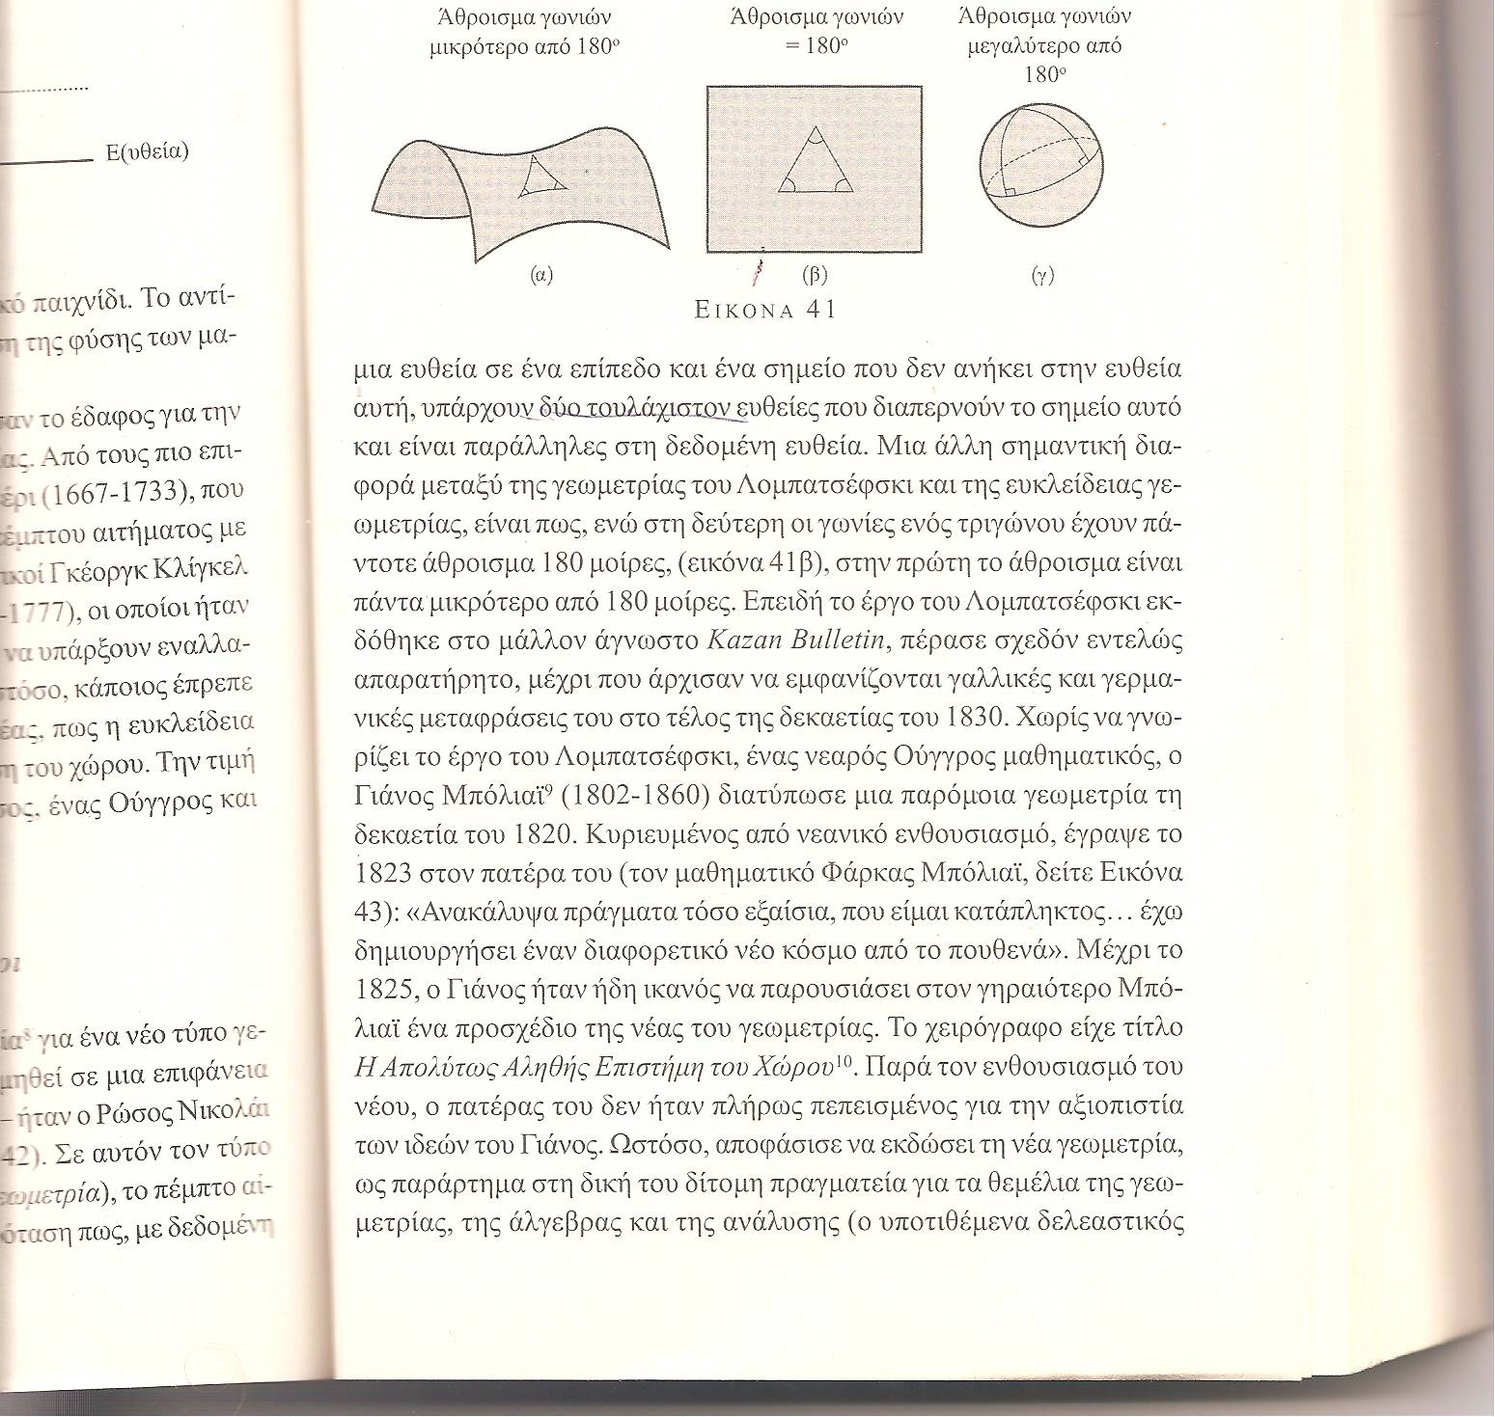

Figure 1: Framework of the Hyperbolic Geometry

A similar Geometry was introduced independently by the young Hungarian mathematician Janos Bolyai (1802-1860). Analogous ideas where stated, also independently, by the great German mathematician Carl Friedrich Gauss (1777-1855) and by the Professor of Law Ferdinand Swickard (1780-1859). However, both of them never decided to publish their ideas. The reason was probably the fact that in their era, which was dominated by the Immanuel Kant’s (1724-1804) philosophical belief that the Euclidean Geometry is an absolute truth {Muller, 1881), such kind of ideas could be considered as a philosophical heresy.

However, Bernhard Riemann (1826-1866), one of the Gauss’s students, in a historic lecture performed at the University of Göttingen on June 10th, 1854 proved that the Hyperbolic Geometry is not the only possible non Euclidean Geometry and, as an example, he introduced the Elliptic Geometry, which is developed on a sphere’s surface (Figure 2). It can be easily understood that in this type of Geometry all curves, including straight lines, are closed, while the shortest path between two points is the smaller arrow of a great circle of the sphere - whose centre coincides with the centre of the sphere - defined by those points. Also, no parallel to a given line can be drawn from a point outside of it, as it happens for example with any two meridians which, although they look like being parallel near the equator, they finally meet at the two poles of the sphere. Further, the sum of the angles of a triangle is always greater than 180º. Obviously, in a small distance around an observer, the Euclidean arises as a special case of the Elliptic Geometry.

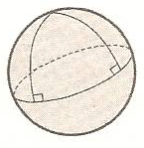

Figure 2: Framework of the Elliptic Geometry

Riemann advanced his ideas by defining analogous Geometries in spaces with more than three dimensions. In particular, Einstein’s General Relativity Theory was developed by using the Riemann’s principles in a 4-dimensional space with its fourth dimension corresponding to time. Riemann gave also an accurate definition of the curvature of a curve or a surface. His idea was to introduce a collection of numbers at every point in space, known as the curvature’s tensor, which would describe how much it was bent or curved. This idea gave genesis to Differential Geometry that connected Geometry with Mathematical Analysis, as the Descartes Analytic Geometry had done before with Geometry and Linear Algebra.

The development of the non Euclidean Geometries caused a real sock to the Platonists, because the Euclidean Geometry was considered until that time as the strongest component of their abstract and unchanged “universe of mathematics”. Since then many people began to suspect that mathematics could finally be a human invention rather than a discovery.

However, a greater sock followed after a while, connected to the development of the Set Theory by Georg Cantor (!845-1918). In fact, the paradoxes appeared in this theory between the end of the 19th and the beginning of the 20th century (Shapiro, 2000), gave the reason to the German mathematician Ernst Zermelo (1871-1953), following the road opened by Euclid for Geometry many centuries ago, to suggest in 1908 a way of restating the Set Theory in terms of a system of axioms. As a result, the paradoxes were by-passed through a careful statement of the corresponding axioms so that to blockade contradictory notions like “the set of all the sets”, which happens to be a member of its self (Russell’s paradox)! The axiomatic system of Zermelo was enriched by Fraenkel (1922) and was further improved by Von Neumann (1925), so that everything seemed to work well.

But gradually one of those axioms started to cause headache to the mathematicians. This was the axiom of choice stating that, if X is a set of non empty sets, then one can choose a unique element from each of these sets in order to create a new set Y. When X is a finite set, or when it is an infinite set but we know the rule under which the choice is made, then the above statement is obvious. The problem is located when X is an infinite set and the rule of the choice is unknown. In this case the choice does never end and the existence of Y becomes a matter of faith. For example, assuming that X is an infinite set of pairs of shoes, if we decide to choose always the right shoe from each pair, then there is no problem. On the contrary, if X is an infinite set of pairs of stockings, then obviously we have a problem with the choice.

This disadvantage made the mathematicians to start thinking, as it had happened with the fifth Euclid’s axiom, if the axiom of choice could be either proved or by-passed with the help of the other axioms. The answer to this question was partially given by Curt Gödel (1940), who proved that the axiom of choice as well as the Cantor’s continuum hypothesis are consistent to the other Zermelo-Fraenkel axioms; i.e. they cannot be contradicted by them. In particular, for the continuum hypothesis this remains true even if the axiom of choice is added to the other Zermelo-Fraenkel axioms. The Gödel’s result was completed by the American mathematician Paul Cohen (1934-2007), who proved in 1963 that the axiom of choice and the continuum hypothesis cannot also be proved by the other axioms of Set Theory and that this is true for the continuum hypothesis even if the axiom of choice is added to the other axioms (Cohen, 1966). The Cohen’s combined with the Gödel’s result, shows that the axiom of choice and the continuum hypothesis are independent from the other axioms of Set Theory. Therefore, considering the continuum hypothesis as an axiom and adding it to the system of the Zermelo-Fraenkel axioms, one can create (INVENT) four different theories for the Sets: The first one by including to it both the axioms of choice and the continuum, the next two by including only one of them in each case and the fourth one by including none of them!

The fundamental role of the Set Theory for the whole spectre of mathematics made this new sock more intense for the Platonists, although they didn’t seem to retreat from their positions claiming that the four different Set Theories pre-existed in the universe of mathematics. Gödel, who believed that the mathematical truth is indeed independent from humans, in an article published in 1947 wrote that there exists a kind of mathematical intuition that makes one to catch directly the mathematical notions in a way analogous to the natural notions.

It must be underlined here that Gödel (1906-1978) became widely known mainly for his two incompleteness theorems published in 1931, one year after getting his Ph.D. degree (Franzen, 2005). These theorems state that, if S is a consistent formal system consisting of a finite set of axioms and rules then:
- S is incomplete, i.e. there exist propositions which cannot be either proved or refuted inside S , and
- Its consistency cannot be proved inside S.

The incompleteness theorems caused a strong earthquake to the mathematical and philosophical world, putting, among others, a definite end to the program of the leader of formalism David Hilbert (1862-1943) about a complete and consistent -i.e. not permitting the creation of absurd situations- axiomatic development of all branches of mathematics (Shapiro, 2000). In fact, according to the second theorem there is no system that can prove the consistency of another system, since it has first to prove its own consistency! Therefore, the best to hope is that the statement of a certain system’s axioms, although it cannot be complete (first theorem), it is consistent.

It must be clarified that the incompleteness theorems do not imply that some truths will never be known, neither that the human ability of understanding is in a way restricted, but they simply underline the weaknesses and deficiencies of the typical systems.

It was normally expected that the proof of the incompleteness theorems would stagger the people’s confidence for the effectiveness of mathematics, but the completely opposite was actually happened! In fact, the amazing success of mathematics in the natural theories about the Universe the decades before and after the publication of the Gödel’s theorems, made it - supported by the introduction of new mathematical branches, like Probability, Statistics, Operational Research, Fractals, Non Linear Dynamics, Fuzzy Logic, etc. - to be more and more essential for the understanding not of the real world only, but also of almost all human activities.

As an example, the Belgian mathematician and astronomer Adolphe Quetelet (1796-1874) was among the first to apply Statistics to Social Sciences planning what he called the Social Physics. He introduced the concept of the “average man” characterized by the mean values of measure variables that follow the Gauss’s normal distribution. He collected data about many such variables like crime, marriage and suicide rates, biological and spiritual human characteristics, etc.

It is recalled that the graph of a canonical distribution is a curve having the form of a church-bell, which is symmetric around its mean value μ (Figure 3).
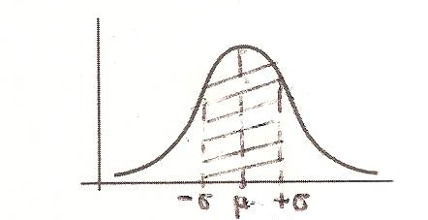

Figure 3: Graph of the normal distribution

Before Quetelet’s observations this curve was known as “the errors’ curve”, because it was observed that it appears in all kinds of errors around the mean values in astronomical measurements. Using the known method of the Integral Calculus for calculating the area under a curve it can be shown that in a canonical distribution 68.2 % of the corresponding data take values in the area defined by one standard deviation σ in each side of the mean value μ (see Figure 3). For example, if the mean value of the heights of a large enough human population is 170 cm and the standard deviation is 20, then 68.2% of those people have heights between 150 and 190 cm. Also, the probability of a person to have a height between 170 and 190 cm is 38.1%. Conclusively, in this case Probability and Statistics are completing each other.

4. The Consideration of Mathematics as a Human Invention and Intermediate Theories.
In contrast to Platonists, there are many people in today who believe that mathematics is a pure human invention. Kasner & Newman (1989) note characteristically: “It looks strange to us that such a theory [Platonism] could ever exist…… The non Euclidean Geometries provide now a strong proof that mathematics is a creature of the human mind, being only under the restrictions imposed by the laws of reasoning”..

Cognitive scientists and psychologists have produced in our days a series of arguments supporting the correlation of mathematics with the human mind. These arguments are mainly based on the data of many experiments concerning the neuro-mapping of the human brains during the performance of proper mathematical activities. An attributive statement from these sources comes from Lakoff and Nunez (2000) claiming that mathematics was created by the humans, who are also responsible for its preservation and further extension.

Nevertheless, the most convincing argument comes from Sir Michael Atiyah (1995), one of the top mathematicians of the 20th century and it has as follows: The mathematical notion with the greater probability to exist independently from human mind is the natural numbers. In fact, even Leopold Kronecker (1823-1891), one of the main supporters of intuitionism, used to say that “God created the natural numbers, while everything else was created by humans” (Shapiro, 2000). Let us now imagine that there exists a jellyfish having the ability of thinking logically, which is living completely isolated in the depths of the ocean. In such a pure continuum there is nothing to be measured, therefore it is impossible for the jellyfish to INVENT by abstraction the notion of the natural numbers. One could disagree with the use of the hypothetical universe of the jellyfish to support the above argument, claiming that each hypothesis must be examined within the existing real Universe. But, such a claim is equivalent of accepting that the notion of natural numbers depends on the human experiences and therefore that it is a human invention.

Sir Atiyah (1995) also notes that, since the human brains was developed in order to confront the natural world, it is not so surprising that it created mathematics in a way compatible to this purpose. This, according to Atiyah, explains in part the unreasonable effectiveness of mathematics in the natural sciences (Winger, 1960), although it leaves open the “pathetic” (Livio, 2009) part of this effectiveness. A possible explanation for the last one, Atiyah continues, could be found to the theoretical nature of mathematics that enables us to move up and down with comfort.

However, views have been also appeared putting the truth somewhere in the middle between the two extreme theories that mathematics are discovered or invented. Livio (2009, Chapter 9) for instance, claims that mathematics is a mixture of human discoveries and inventions. The axioms and definitions are inventions, like it happens with the rules of chess, while the related theorems are discoveries. In many cases theorems are created by the proofs, i.e. the mathematicians study first what they can prove, wherefrom they derive the theorems. In other cases, like Archimedes described in his “Method”, the answer to a problem can be firstly found intuitively or empirically and the proof follows.

As an example, Livio (2009) considers the prime numbers, which as a notion is an invention of the ancient Greek mathematicians, while all the theorems related to them are discoveries. The ancient Babylonians, Egyptians and Chinese never used prime numbers in their mathematics, but it is not logical to consider that they didn’t discover them. They simply managed to progress their mathematics without them, like the United Kingdom is governed without a unique written Constitution!

Nicholson (2012) invokes the introduced by Pirsig (1974, 1991) philosophical system of the “Metaphysics of Quality” to support, among others, a belief analogous to the above Livio’s view and to give an explanation of the Winger’s (1960) enigma about the unreasonable effectiveness of mathematics in the natural sciences.

That mathematics follows quality has been claimed in many different ways by many different people, especially working mathematicians. One of the best arguments is that of the famous Princeton mathematician Goro Shimura. Discussing his famous Taniyama-Shimura conjecture, whose proof led to the proof by Andrew Wiles (1995) of Fermat’s last Theorem, Shimura said: “Mathematics should contain goodness….. It is a rather crude philosophy, but one can always take it as a starting point….. I might say that the conjecture stemmed from that philosophy of goodness. Most mathematicians do mathematics from an aesthetic point of view and the philosophy of goodness comes from my aesthetic viewpoint” (Singh, 1997, p. 210).

According to Pirsig (1991) “quality” is a non definable entity that can be understood by splitting it to the “dynamic” and to the “static” quality, which they act like a ratchet: The dynamic quality is the constant stimulus to move to something better, to ratchet up, whereas the static quality is the latch of the ratchet itself, the making tangible of the motion up into something concrete, which will prevent falling down into something worse. In other words, the dynamic quality is the creative urge, whereas the static quality is what is created in response.

Nicholson (2012) argues that mathematics is invented insofar as it is a process following dynamic quality and it is discovered insofar as it is a process of slashing out previously unknown consequences within static patterns of quality that are mathematics as it stands. Further, his explanation about the Wingers enigma is based to the argument that, since nature and mathematics are both patterns of static quality created by following dynamic quality, it is not surprising that they arrive to the same conclusions.

We shall close this discussion with an interesting remark of Davis & Hersh (1981) stated in their book “The Mathematical Experience” that, the middle working mathematician is a Platonist during the working days of the week and a formalist (therefore it considers mathematics as a human invention) on Sundays. This means that when he/she is working on mathematics he/she is convinced that he/she is faced with an objective reality, but when he/she is asked to provide a philosophical explanation of this reality, he/she considers easier to answer that he/she does not believe it!

CONCLUSIONS

From the discussion performed in this paper it turns out that there exist many indications in our days that mathematics is invented by humans. Nevertheless, the corresponding arguments have not been proved strong enough until now to overturn in a categorical way the platonic view that mathematics is independent from the human mind and therefore it is a human discovery. Accordingly, a possible scenario is that mathematics is a mixture of human discoveries and inventions. All these scenarios are connected and they try to explain the phenomenon which was termed by Wigner (1960) as the unreasonable effectiveness of mathematics in the natural sciences.

At any case, all the above belong to the sphere of philosophy, which focuses in general to the continuous study rather of such kind of questions, than to finding definite answers about them. This study improves our conception about the several possibilities, enriches our spiritual imagination and decreases the dogmatic perception that restricts the power of reasoning in favour of the conjecture (Russell, 1912).

Adopting a Livio’s (2009, Chapter 9) remark, we believe that the only certain conclusion that can be obtained from such a discussion is that mathematics constitutes a part of the human civilization. For example, the later European mathematicians, following the road opened by Euclid for Geometry many centuries ago, not only used the axiomatic method for the development of other branches of mathematics, like Zermelo did for the Set Theory, but they also developed the philosophical theory of formalism, whose target was - until the proof of the Gödel’s incompleteness theorems - a general axiomatization of mathematics.
In the Chinese philosophy Yin and Yang represent all the opposite principles. Nevertheless, it is important to pay attention to the fact that these two aspects complete rather than opposing each other, with the one containing some part of the other (Ma Li, 2005). According to these lines, each of the several philosophies on mathematics has its own importance and advantages, but what it matters more is to find a proper balance among them.

In fact, the implications that the philosophical ideas connected to mathematics have on Mathematics Education are serious and important. This is of course a theme that needs a separate and extensive analysis, which is out of the scopes of the present work. Nevertheless, it is obvious that the required balance among these ideas could prevent in future the “earthquakes” in the sensitive area of teaching and learning mathematics - like it happened in the near past with the unsuccessful introduction of the “new mathematics” in school education - that have so much distressed students and teachers during the last years.

REFERENCES

Atiyah, M.F. (1995), Book review: Conversations on Mind, Matter and Mathematics (, J.-P. Changeux & A. Connes), Times Higher Education Supplement (September, 29)
Changeux, J.-P.& Connes, A. (1995), Conversations on Mind, Matter and Mathematics, Princeton University Press, Princeton.
Cohen , P.J. (1966), Set Theory and the Continuum Hypothesis, Benjamin, New York.
Davis, P.J. & Hersh, R. (1981), The Mathematical Experience, Birkhauser, Boston.
Franzen, T. (2005), Gödel’s Theorem: An Incomplete Guide to its Use and Abuse, A.K. Peters, Wellesley, Mass.., USA
Gödel, C. (1940), The Consistency of the Axiom of Choice and of the Generalized Continuum Hypothesis with the Axioms of Set Theory, Princeton University Press, Princeton, USA.
Grassmann, G. (1844), Die Lineale Ausdehnungsiehre, Wiegand, Leipzig. English Translation, 1995 by L. Kannenberg. Linear Extension: A New Branch of Mathematics, Open Court, Chicago.
Hamming, R. (1980), The unreasonable effectiveness of mathematics, American Mathematical Monthly, 87(2), 81-90.
Hardy, G.H. (1940), The Apology of a Mathematician, Cambridge University Press, Cambridge, UK.
Kasner, E. & Newman, J.R. (1989), Mathematics and the Imagination, Tempus Books, Reelmond, Washington.
Lakoff, G. & Nunez, R. E. (2000), Where Mathematics Comes From, Basic Books, New York..
Livio, M. (2009), Is God a Mathematician? Simon & Schuster, London.
Lopez-Permouth, S. (2009), Matrix Representations of Skew Polynomial Rings with Semisimple Coefficient Rings, Contemporary Mathematics, 480, 289-295.
Ma, Li (2005), Towards a Yin-Yang Balance in Mathematics Education, Proceedings 4th Mediterranean Conference on Mathematics Education, Palermo, Italy, pp.685-689.
Majid, S. (2006), What is a Quantum Group? Notices of the American Math. Soc., 53, 30-31.
Muller, F.M. (1881), Immanuel Kant’s Critique of Pure Reason, Macmillan, London (translation of the original Kant’s work, 1781)
Nicholson, J.S. (2012), A Perspective on Winger’s “Unreasonable Effectiveness of Mathematics’, Notices of the American Math. Soc., 59, 38-42.
Pesic, P. (2007), Beyond Geometry: Classic Papers from Riemann to Einstein, Dover Publications, Mineola, New York.
Pirsig, R.M. (1974), Zen and the Art of Motorcycle Maintenance, William Morrow and Company, New York.
Pirsig, R.M. (1991), Lila, Bantam Books, New York
Putnam, H. (1975), What is Mathematical Truth? Mathematics, Matter and Method, Cambridge University Press, Cambridge, 2nd Edition, pp.60-78.
Russell, B. (1912), The Problems of Philosophy, Home University Library, London (retyped by Oxford University Press, Oxford, 1997).
Shapiro, S. (2000), Thinking about Mathematics, Oxford University Press, Oxford.
Shing, S.L. (1997), Fermat’s Last Theorem, Fourth Estate, London.
Tegmark, M. (2014), Our Mathematical Universe: My Quest to the Ultimate Reality, A. Knopf, New York.
Voskoglou, Μ.Gr. (1982), A Contribution to the Study of Rings, Ph. D. Thesis, Department of Mathematics, University of Patras, Patras, Greece (in Greek language).
Wiles, A. (1995), Modular Elliptic Curves and Fermat’s Last Theorem, Annals of Mathematics, 142, 443-551.
Wigner, E.P. (1960), The unreasonable effectiveness of mathematics in the natural sciences, Communications on Pure and Applied Mathematics, 13, 1-14 (Richard Courant Lecture, New York University, 11-5-1959).

Considering the architecture of the atoms, which is transferred to the planetic systems around the stars, to the galaxies and finally to all entities of the Universe rotating around its centre, I am frequently thinking of the Universe as being an enormous “body”, in an analogue to the human bodies. The “brains” of this body correspond to the “Highest Power” that has created it, which power is expressed by the notion of the God in the several human religions. I wish to be able to prove mathematically this conjecture, but unfortunately I am feeling too weak to attempt such a thing.
The famous astrophysicist of the Space Telescope Institute in Baltimore and best selling author Mario Livio in his book “Is God a Mathematician?” explores mathematical ideas from Pythagoras to the present day as he shows us how ingenious thoughts have led to ever deeper insights into our world. Livio’s book was my main source in writing this article.
From a point of the plane lying outside a given straight line only one parallel can be drawn to this line. According to the original Euclid’s statement, two straight lines of the plane intersecting a third one such that the two internal angles formed in the one side have sum less than two right angles, then the two lines when extended are always intersected from this side.
All indications show that even Euclid was not completely satisfied with this axiom, which is not used in the proofs of the first 28 propositions in his “Elements”.
The title of the lecture was “On the hypotheses which underline Geometry”. An English translation of this lecture can be found in Pesic (2007).
Spaces with more than three dimensions were first introduced by the German teacher Hermann Grassmann (1809-1877), a polymath lacking university studies in mathematics. His ideas, published in his book entitled “Theory of Linear Extension: A New Branch of Mathematics (Grassmann, 1844) gave genesis to the Linear Algebra.
The continuum hypothesis, which was the first of the 23 unsolved mathematical problems presented in 1900 by Hilbert at the International Conference of Mathematics in Paris, states that the set of real numbers has the minimal possible cardinality which is greater than the cardinality of the set of non negative integers. This is equivalent to saying that the cardinality of the power set of the non negative integers is equal to the cardinality of the real numbers. In an analogous way, the generalized continuum hypothesis states that the cardinality of the power set of each infinite set is the smaller cardinality which is greater than the cardinality of this set.
On the other hand, a Platonist could oppose that the fact that it would be impossible for the jellyfish to DISCOVER the natural numbers does not mean that this notion does not exist in the eternal “universe of mathematical forms”!

